Web Technologies Lab
(Lab 2)
Name | Fatima Khan.
Registration No | FA24-BCS-033-B.
Submitted To | Sir Usman Akram.
Date of Submission | 20th October 2026.

Lab 2 — Responsive Navbar and Grid Drill
Difficulty: Easy–Medium · Covers: Lectures 7–10 · Folder: lab-2/
A focused, smaller-scale rehearsal for Assignment 2: build just a responsive navbar (logo left, links center, cart icon right, collapsing into a hamburger menu below 768px) and a 4-column-desktop / 2-column-tablet / 1-column-phone product grid, using Flexbox or Grid plus Bootstrap or Tailwind. Content can be placeholder text/images — the point is the responsive mechanics, not the final design.
Deliverables in lab-2/: index.html, your CSS/framework files, and your completion PDF (with screenshots at phone/tablet/desktop widths).

Code:
1. <!DOCTYPE html>
2. <html lang="en">
3. <head>
4. <meta charset="UTF-8">
5. <meta name="viewport" content="width=device-width, initial-scale=1">
6. <title>Lab 2</title>
7. <link rel="stylesheet" href="bootstrap.min.css">
8. <link rel="stylesheet" href="style.css">
9. </head>
10. <body>
11.
12. <nav class="navbar navbar-expand-md bg-light">
13. <div class="container">
14. <a class="navbar-brand" href="#"><img src="logo.png" alt="Logo" height="40"></a>
15. <button class="navbar-toggler" type="button" data-bs-toggle="collapse" data-bs-target="#menu">
16. <span class="navbar-toggler-icon"></span>
17. </button>
18. <div class="collapse navbar-collapse" id="menu">
19. <ul class="navbar-nav mx-auto">
20. <li class="nav-item"><a class="nav-link" href="#">Home</a></li>
21. <li class="nav-item"><a class="nav-link" href="#">Products</a></li>
22. <li class="nav-item"><a class="nav-link" href="#">Contact</a></li>
23. </ul>
24. <a class="nav-link" href="#">🛒</a>
25. </div>
26. </div>
27. </nav>
28.
29. <div class="container my-4">
30. <h1>Products</h1>
31. <div class="grid">
32. <div class="item">
33. <img src="images/1.avif" alt="Product 1">
34. <h2>Product 1</h2>
35. <p>Rs. 1100</p>
36. </div>
37. <div class="item">
38. <img src="images/2.avif" alt="Product 2">
39. <h2>Product 2</h2>
40. <p>Rs. 1200</p>
41. </div>
42. <div class="item">
43. <img src="images/3.avif" alt="Product 3">
44. <h2>Product 3</h2>
45. <p>Rs. 1300</p>
46. </div>
47. <div class="item">
48. <img src="images/4.avif" alt="Product 4">
49. <h2>Product 4</h2>
50. <p>Rs. 1400</p>
51. </div>
52. <div class="item">
53. <img src="images/5.avif" alt="Product 5">
54. <h2>Product 5</h2>
55. <p>Rs. 1500</p>
56. </div>
57. <div class="item">
58. <img src="images/6.avif" alt="Product 6">
59. <h2>Product 6</h2>
60. <p>Rs. 1600</p>
61. </div>
62. <div class="item">
63. <img src="images/7.avif" alt="Product 7">
64. <h2>Product 7</h2>
65. <p>Rs. 1700</p>
66. </div>
67. <div class="item">
68. <img src="images/8.avif" alt="Product 8">
69. <h2>Product 8</h2>
70. <p>Rs. 1800</p>
71. </div>
72. </div>
73. </div>
74.
75. <script src="bootstrap.bundle.min.js"></script>
76. </body>
77. </html>
78.

Output:
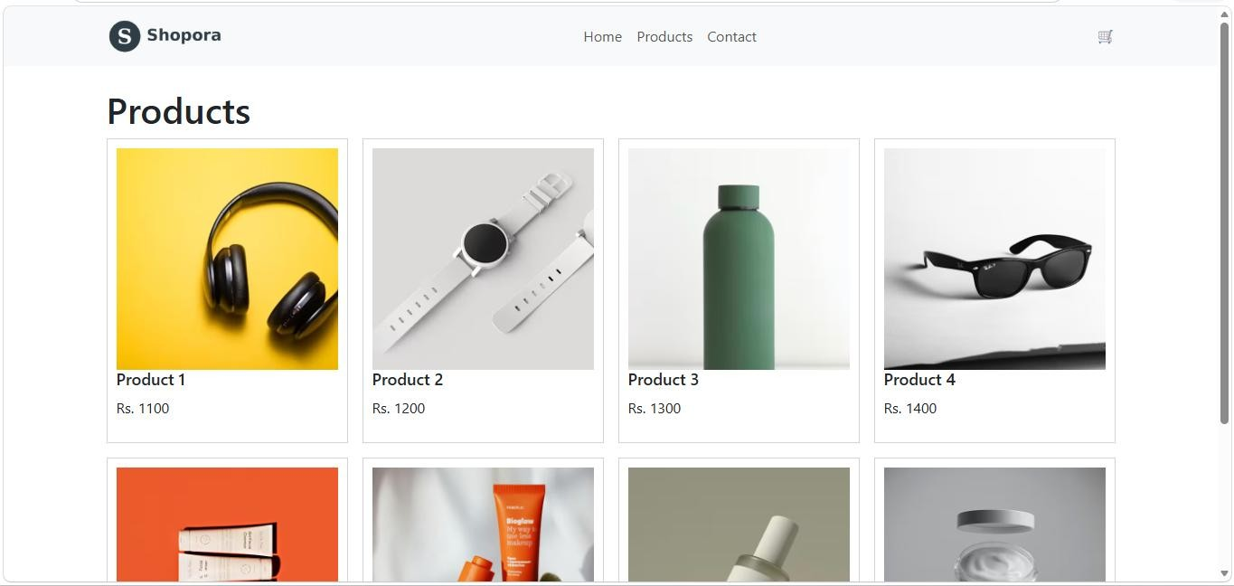
Desktop (1280px)

Phone (
375
px
)

